**Cloning a repository**

1. On GitHub.com, navigate to the main page of the repository.
2. Above the list of files, click  **Code**.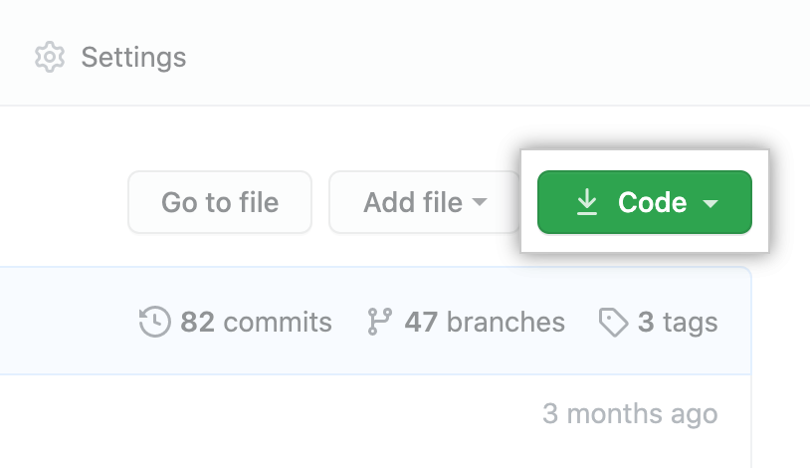
3. Copy the URL for the repository.
   * To clone the repository using HTTPS, under "HTTPS", click .

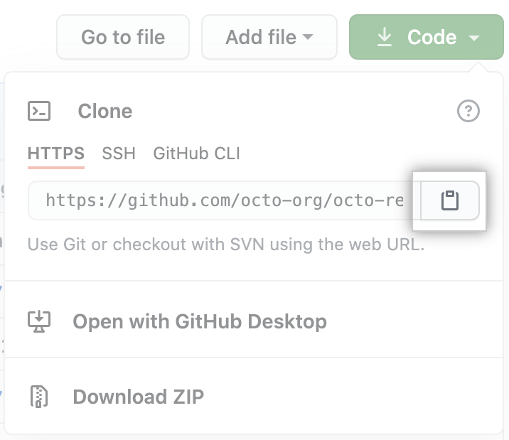

Open GitKraken – go to file – clone repo

Browse to the TeamWork folder in OneDrive and then paste the url you copied from GitHub in the the URL box. Click ‘Clone the Repo’.

